#include<stdio.h>

#include<stdlib.h>

struct node {

int data;

struct node *next;

};

struct node *head = NULL;

void display() {

printf("Elements are: ");

struct node *ptr = head;

while (ptr != NULL) {

printf("%d -> ", ptr->data);

ptr = ptr->next;

}

printf("NULL\n");

}

void insert_begin() {

struct node *temp = (struct node*)malloc(sizeof(struct node));

printf("Enter the value to be inserted: ");

scanf("%d", &temp->data);

temp->next = head;

head = temp;

}

void delete_begin() {

if (head == NULL) {

printf("List is empty. Deletion not possible.\n");

return;

}

struct node *temp = head;

head = head->next;

printf("Element deleted from the beginning: %d\n", temp->data);

free(temp);

}

void delete_end() {

if (head == NULL) {

printf("List is empty. Deletion not possible.\n");

return;

}

struct node *temp, *prev;

temp = head;

while (temp->next != NULL) {

prev = temp;

temp = temp->next;

}

if (temp == head) {

head = NULL;

} else {

prev->next = NULL;

}

printf("Element deleted from the end: %d\n", temp->data);

free(temp);

}

void delete_at_position() {

int position;

printf("Enter the position to delete: ");

scanf("%d", &position);

if (head == NULL) {

printf("List is empty. Deletion not possible.\n");

return;

}

struct node *temp, *prev;

temp = head;

if (position == 0) {

head = head->next;

printf("Element at position %d deleted successfully.\n", position);

free(temp);

return;

}

for (int i = 0; temp != NULL && i < position; i++) {

prev = temp;

temp = temp->next;

}

if (temp == NULL) {

printf("Position %d is out of bounds.\n", position);

return;

}

prev->next = temp->next;

printf("Element at position %d deleted successfully.\n", position);

free(temp);

}

int main() {

int choice;

while (1) {

printf("\n 1. to insert at the beginning\n 2. to delete beginning\n 3. to delete at end\n 4. to delete at any position\n 5. to display\n 6. to exit\n");

printf("Enter your choice: ");

scanf("%d", &choice);

switch (choice) {

case 1:

insert_begin();

break;

case 2:

delete_begin();

break;

case 3:

delete_end();

break;

case 4:

delete_at_position();

break;

case 5:

display();

break;

case 6:

exit(0);

break;

default:

printf("Enter the correct choice\n");

break;

}

}

return 0;

}

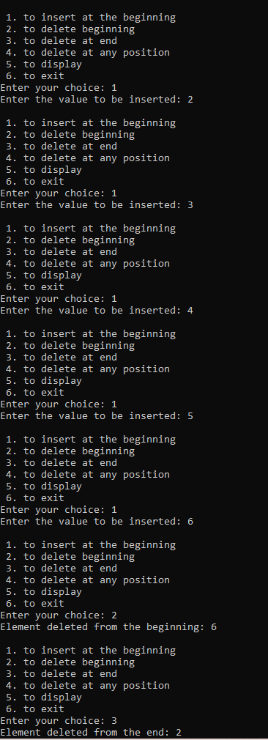

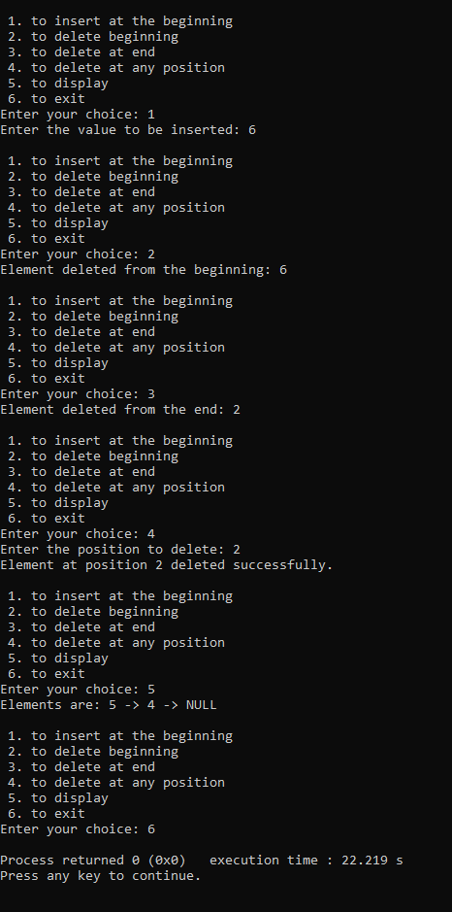

**Leet code- reverse linked list ll**

/**

* Definition for singly-linked list.

* struct ListNode {

* int val;

* struct ListNode *next;

* };

*/

struct ListNode* reverseBetween(struct ListNode* start, int a, int b)

{

a-=1;

b-=1;

struct ListNode *node1=NULL,*node2=NULL,*nodeb=NULL,*nodea=NULL,*ptr=start;

int c=0;

while(ptr!=NULL)

{

if(c==a-1)

nodeb=ptr;

else if(c==a)

node1=ptr;

else if(c==b)

node2=ptr;

else if(c==b+1)

{

nodea=ptr;

break;

}

c+=1;

ptr=ptr->next;

}

struct ListNode*pre=nodea,*temp;

ptr=start;

c=0;

while(ptr!=NULL)

{

if(c>=a && c<b)

{

temp=ptr->next;

ptr->next=pre;

pre=ptr;

ptr=temp;

}

else if(c==b)

{

ptr->next=pre;

if(a==0)

start=ptr;

else

nodeb->next=ptr;

break;

}

else

ptr=ptr->next;

c+=1;

}

return start;

}

**output**

